Abstract:

Introduction:
A challenge during the initial evaluation of the poisoned patient is to prognosticate the severity of an ingestion from incomplete. Admitting poisoned patients to the intensive care unit (ICU) who do not require that level of care delays the care of those poisoned patients need and reduces ICU capacity for other patients. For example, admitting all ingestions of more than 450 mg of bupropion to the ICU for 24 hours to observe for ventricular dysrhythmias, leads to approximately 2,000 unnecessary ICU admissions across the United States each year¹. (place for continued references to all those studies showing high # of admits but low # of deaths; not sure how many to use to make the case).
A clinical decision support tool would help guide emergency physicians in selecting the level of care for poisoned patients and in standardizing recommendations from medical toxicologists. It is difficult to make one tool that accurately risk-stratifies the variety of physiological derangements that poisoned patients can have. [Poison Severity Score]
Something here about need for better discrimination.
Medical toxicologists in the Netherlands developed INTOXICATE, a clinical decision support tool to help physicians determine whether poisoned patients required ICU admission or could be safely managed on a general medical floor². INTOXICATE identified easily obtainable clinical covariates as predictors of ICU requirement (defined as mechanical ventilation and/or vasopressors in the first 24 hours of ICU stay, or death at any point during hospitalization) in patients who were admitted to the ICU and received a diagnosis of intoxication. INTOXICATE was internally validated by resampling and correctly identified 34% of ICU patients who did not ultimately require ICU-level care. If applying INTOXICATE has a similar effect in the American healthcare system, it would simultaneously improve the care of poisoned patients and increase access to the ICU.
This outcome, however, assumes INTOXICATE would only be applied to patients who would otherwise have been admitted to the ICU. It remains unclear how having access to such a tool would change clinical decision making. For such a tool to have use in reducing ICU admissions, it must not only be externally valid, but also demonstrate sufficient specificity such as to not bias practitioners to admit patients who do not need ICU admission and would not have been admitted in the absence of a positive score.
The goal of this study was to externally validate INTOXICATE in as a clinical decision tool for the emergency physician or bedside toxicologist to use in the initial evaluation of a poisoned patient.
Methods:
Setting
We conducted a retrospective study of toxicology consultations at one urban tertiary care center with a 24/7 bedside toxicology service. We screened all consultations from from January 2023 to April 2024. We included patients aged 12-18 even though the original study did not and analyzed them as a distinct subgroup. We included adolescents because they comprise X% of our consultations and 31% of nationwide calls for intentional ingestions(1,2) and have cardiovascular and neurological responses to xenobiotics comparable to adults. We excluded patients younger than 12 and those with missing data.
Definitions
INTOXICATE assigns each patient a score, the INTOXICATE Risk Score (IRS) based on certain clinical features. For example, a patient receives 1 point if the heart rate is between 75 to 85 beats per minute and 2 points if between 85 to 95 beats per minute. The sum of the scores across all clinical features is the IRS. We refer the reader to (3) for detail on calculating IRS.
INTOXICATE defined dysrhythmia as one of the following cardiac rhythms in combination with hemodynamic instability in the 24 hours before ICU admission: arrhythmia, tachycardia, second or third-degree AV block, atrial fibrillation with a ventricular rate greater than 120 beats per minute.

We did not distinguish between discharge from the Emergency Department and transfer from the Emergency Department to Psychiatry.

Statistical analyses
Our outcome measure was the inter-rater reliability between the INTOXICATE’s prediction disposition and the treating physician's decision. We chose this measure instead of overall agreement to capture the degree to which INTOXICATE agrees with toxicologist decision-making beyond chance.

Results:
Description of Data Set. We screened 112 patients, excluded 7 who were under 12 and 2 who had missing data, ultimately including 103 patients for analysis (Figure 1). The median age of the adolescents and adults were, 15 [14-16] and 35 [28-50], respectively, expressed as median [interquartile range], respectively. The proportions of admission to a general medical floor or the ICU were comparable between adolescents and adults (Table 1). There were no statistically significant differences between adolescents and adults in gender, heart rate, actual disposition, respiratory insufficiency, cirrhosis, dysrhythmia, GCS, type of exposure, or other medical reasons for ICU admission. The systolic blood pressure was significantly different, 116 [106-119] and 120 [112-140], respectively, but this difference is unlikely to be clinically meaningful.
Of the 103 patients, 20 (19%) were admitted to the ICU, 16 (16%) to a general medical floor, and 75 (65%) were discharged or transferred directly to psychiatry. INTOXICATE recommended ICU admission for 13/20 (65%) of patients for whom the toxicologist recommended ICU admission, ICU admission for 12 of the 16 (75%) patients for whom admission the toxicologist recommended a general medical floor, and ICU admission for and 36 of the 75 (48%) patients for whom the toxicologist recommended discharge. No patients for whom toxicology recommended a floor admission were admitted to a floor and then transferred to the ICU. No patients who were discharged but for whom INTOXICATE recommended admission returned to any hospital in the metropolitan area in 48 hours. There was no agreement greater than chance between INTOXICATE’s predictions and the bedside toxicologists’ recommendations for either adolescents or adults (Table 2).
Adults. Of the 79 adults, 16 were admitted to the ICU. INTOXICATE and toxicologist agreed that 11 of the 16 (69%) required ICU admission. For the remaining 5, INTOXICATE assigned them a lower risk score because it considered their exposure to be low risk, there was no respiratory insufficiency or dysrhythmia, their GCS scores were 15, their pulses were lower, and they were younger. The median (IQR) pulse in those for whom INTOXICATE and Toxicology recommended ICU admission was 87 (76-104) beats per minute. It was 70 (65-74) beats per minute in the patients for whom Toxicology recommended ICU admission but INTOXICATE did not. The median ages were 38 (30-53) and 30 (25-38), respectively. Neither of these differences were statistically significant. Taking the toxicologist’s recommendation as the gold standard, the sensitivity and specificity of INTOXICATE for patients aged 18-65 were 69% [41-89] and 38% [26-51], respectively, expressed as estimate [95% confidence interval].
INTOXICATE thought 39 people required the ICU because of the converse even though bedside toxicologists did not. The age, median heart rate, and median systolic blood pressure were not significantly different between those for whom INTOXICATE predicted required the ICU and those whom it predicted did not.
Adolescents. Of the 24 adolescents, 4 were admitted to the ICU. INTOXICATE and toxicologist agreed that two of the four (50%) required ICU admission. These patients presented with GCS 10 and 14, and tachycardia. One presented after ingesting an unknown substance. Of the two patients, for whom INTOXICATE did not recommend ICU admission, one presented with an acetaminophen ingestion requiring N-acetylcysteine. INTOXICATE assigned a risk score of 3 because the patient was normotensive, not tachycardic, and had no cirrhosis, respiratory insufficiency, or cardiac dysrhythmia. The other presented with alcohol intoxication and was hypertensive, tachycardic, with GCS = 10 (IRS = 4). In INTOXICATE’s schema, report of alcohol ingestion decreases the odds of ICU admission no matter the vital sign abnormalities. INTOXICATE recommended the ICU requirement for 9 adolescents for whom toxicology did not. These 9 patients presented with different ingestions, but all were tachycardic with median (IQR) of 114 (106 - 115) bpm, and all had a GCS of 15. There were no significant differences in age, HR, SBP, GCS, or presence of respiratory insufficiency, cirrhosis, dysrhythmia, or other reason for ICU admission. Taking the toxicologist’s recommendation as the gold standard, the sensitivity and specificity of INTOXICATE were 50% [1-99] and 55% [33-77], respectively, expressed as estimate [95% confidence interval]. The wide confidence intervals reflect the overall small number of adolescents.
Discussion:
The overall goal of this paper was to externally validate INTOXICATE as a clinical decision tool to identify patients who would not need ICU level of care in the first 24 hours after presentation. We found that INTOXICATE had no clinically significant agreement with the recommendations of bedside toxicologists. The initial derivation study investigated suspected poisoned patients admitted to the ICU. If applied only to patients for whom toxicology recommended ICU admission, INTOXICATE would have reduced ICU admissions by 33% (7/21), consistent with the initial derivation study. However, INTOXICATE is more likely to be used in the Emergency Department to determine the initial level of care, rather than to downgrade care after Toxicology consultation. If applied to all patients Emergency Department patients who received a toxicology consult, INTOXICATE nearly tripled ICU utilization (from 20 to 61). The IRS threshold of 6 points that was chosen by Brandenburg et. al. to minimize false negatives. The threshold may need to be recalibrated.
Variation in practices across health care systems may contribute to the discordance. At the authors’ institution, all patients receiving an N-acetylcysteine infusion or hyperbaric treatment are admitted to the ICU. The agreement between INTOXICATE and the initial disposition may change in health care systems that use a Poison Center-based Toxicology consultation, rather than a bedside one. However, recommendations from Poison Control are inconsistently followed. The degree of evaluation and treatment done in the Emergency Department may vary across healthcare systems. The bedside toxicologist considers features INTOXICATE does not, such as clonus, abnormal EKG intervals, progressive limb swelling, inability to tolerate food or liquid by mouth, or acidemia.
Our study did not investigate all facets of INTOXICATE. INTOXICATE identifies predictors of not needing ICU care, such as acute intoxication with alcohol. In our cohort, Toxicology was not consulted on any patients with alcohol intoxication alone. INTOXICATE identifies respiratory insufficiency, dysrhythmia, cirrhosis, and a nontoxicological reason for ICU admission as predictors of needing ICU care. In this study, all patients admitted to our ICU had either respiratory insufficiency, dysrhythmia, or both. Seven of the 19 patients the bedside toxicologist recommended for discharge had one of those comorbidities. INTOXICATE recommended ICU for all patients with any of the above criteria, suggesting an opportunity to refine criteria such as respiratory insufficiency.
INTOXICATE uses APACHE IV diagnoses to classify ingestions, which may not agree with the bedside toxicologist’s schema. The category Antidepressants, includes SSRIs, tricyclic antidepressants, and lithium. Tachycardia has clinically significantly different prognostic values for each of these xenobiotics. An opioid could be classified as a Street Drug or Analgesic. Carbon monoxide, arsenic, and cyanide have their own category, but household cleaners and pesticides are lumped under under toxins not otherwise specified. The category combination of two subtypes of intoxication is a catch-all for polysubstance intoxications, but Brandenburg (for reasons unknown and not explained in their paper) did not include polysubstance intoxication as a covariate in their model or assign it a risk score. This is particularly important given the significant morbidity and mortality associated with polysubstance intoxications, being implicated in 48-58% of overdose deaths (cited Peppin below, but will find more because that source is specific to unintentional drug overdose and there is definitely plenty more to cite and mention). For 18 out of 28 adult patients (64%), the intoxication type was Intoxicant NOS or Combination.

Conclusions:
Clinical decision rules currently used by X recommend a course of action (e.g., Ottawa Knee/Ankle, Wells’ DVT/PE, Canadian Head CT, PECARN). They were created to help identify patients who would benefit from an action in cases where the risks associated with the action are low (e.g., diagnostic imaging) and the consequences of a false negative are high (e.g., untreated fracture, thromboembolism, or ICH). When these rules are appropriately applied to patients with reasonable pre-test probability of disease based on H&P, just one or two points are sufficient to communicate sufficiently high risk of an outcome to indicate intervention. In contrast, for INTOXICATE, the problem being addressed by the decision rule is the outcome of the decision rule itself - ICU admission - and a slew of non-specific clinical covariates found to have independent (but not independently sufficient!) associations with the outcome are assessed. At this time, INTOXICATE is an arithmetical substitute for the physician’s gauge of pre-test probability, but is not the test itself. In that way, INTOXICATE is more closely related to a mortality prediction score, such as APACHE, and mortality prediction scores are not clinical decision rules. There’s a lot left that could be written for the conclusion, but I think it’s best to shape up the rest of the paper before I conclude it.
Clinical decision tools such as INTOXICATE assume that the level of care a poisoned patient requires can be predicted from a small number of commonly used clinical features, despite the variety of xenobiotics and their variegated effects on the body. Risk-stratification measures for specific ingestants have been quite successful, for example serum concentrations of acetaminophen, salicylate, bupropion HR(4), PO tolerance for caustics, osmolar gap for toxic alcohols. Broader risk stratification tools, in the spirit of INTOXICATE, are useful when a person ingests clinically relevant amounts of multiple substances and when the ingestion is unknown. Our results extend those of Brandenburg by demonstrating that the sensitivity and specificity of INTOXICATE are comparable in the Dutch and American healthcare systems in the original study population, but increase unnecessary ICU utilization in the most likely implementation scenario. Our findings underscore the divide between INTOXICATE’s prediction and the recommendation of bedside toxicologists. Future work may improve INTOXICATE by considering trends in vital signs and focusing on ingestions for whom there is no effective risk stratification tool.

Other points to work in
- Not yet known whether a mortality prediction score, developed for intoxicated patients or the general population, at a certain threshold is an equal or better predictor of ICU requirement than a model developed on ICU patients with known outcomes

References
- Simpson, M. et al. Clinical and electrocardiographic factors associated with adverse cardiovascular events in bupropion exposures. Clin Toxicol 61, 529–535 (2023).
- Brandenburg, R. et al. The need for ICU admission in intoxicated patients: a prediction model. Clin Toxicol 55, 4–11 (2017).
- Han, K. S., Kim, S. J., Lee, E. J., Shin, J. H., Lee, J. S., & Lee, S. W. (2021). Development and validation of new poisoning mortality score system for patients with acute poisoning at the emergency department. Critical care (London, England), 25(1), 29. https://doi.org/10.1186/s13054-020-03408-1
- Idowu, D., Ezema, K., Corcoran, J., & Farkas, A. (2024). The predictive value of heart rate in determining clinical course after a bupropion overdose. Clinical Toxicology, 1–7. https://doi.org/10.1080/15563650.2024.2347514
- Peppin, J. F., Raffa, R. B., & Schatman, M. E. (2020). The Polysubstance Overdose-Death Crisis. Journal of pain research, 13, 3405–3408. https://doi.org/10.2147/JPR.S295715

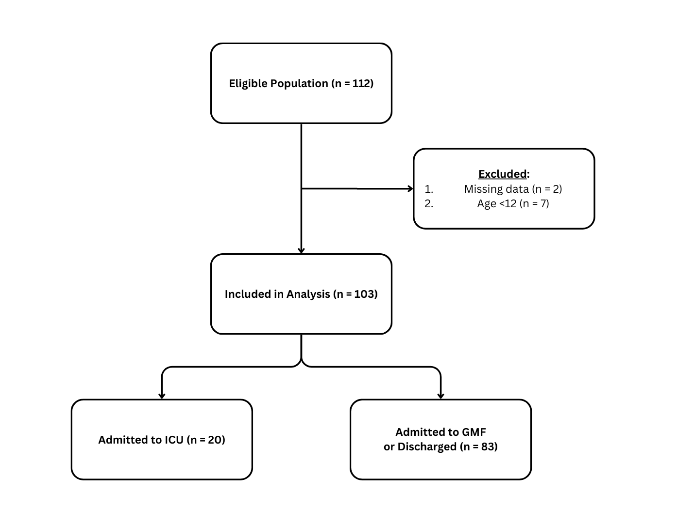
Figure 1. Screening and Inclusion of Patients.

Characteristic | Adolescent, N = 24¹ | Adult, N = 79¹ | p-value²
Age | 15 (14, 16) | 35 (28, 50) | <0.001
Gender |  |  | 0.2
F | 13 (54%) | 40 (51%)
M | 10 (42%) | 39 (49%)
NB | 1 (4.2%) | 0 (0%)
Pulse | 99 (89, 110) | 90 (72, 107) | 0.071
SBP | 116 (106, 119) | 120 (112, 140) | 0.033
Actual Disposition |  |  | 0.5
Discharge | 18 (75%) | 49 (62%)
GMF | 2 (8.3%) | 14 (18%)
ICU | 4 (17%) | 16 (20%)
Respiratory Insufficiency | 2 (8.3%) | 16 (20%) | 0.2
Cirrhosis | 0 (0%) | 2 (2.5%) | >0.9
Dysrhythmia | 12 (50%) | 29 (37%) | 0.3
Secondary Reason for ICU Admission | 0 (0%) | 1 (1.3%) | >0.9
GCS |  |  | 0.024
3 | 0 (0%) | 3 (3.8%)
5 | 0 (0%) | 1 (1.3%)
10 | 3 (13%) | 0 (0%)
11 | 0 (0%) | 1 (1.3%)
12 | 0 (0%) | 1 (1.3%)
13 | 0 (0%) | 2 (2.5%)
14 | 3 (13%) | 2 (2.5%)
15 | 18 (75%) | 69 (87%)
Exposure Category |  |  | 0.11
Alcohol | 2 (8.3%) | 5 (6.3%)
Analgesic | 6 (25%) | 11 (14%)
Antidepressants | 5 (21%) | 11 (14%)
CO, As, CN | 0 (0%) | 9 (11%)
Combination | 1 (4.2%) | 16 (20%)
Sedatives | 0 (0%) | 6 (7.6%)
Street Drugs | 5 (21%) | 10 (13%)
Unknown | 5 (21%) | 11 (14%)
¹ Median (IQR); n (%)
² Wilcoxon rank sum test; Fisher’s exact test; Pearson’s Chi-squared test

Table 1. GMF, general medical floor.

 | Adolescent |  |  |  |  | Adult
 | Predicted Disposition |  |  |  |  | Predicted Disposition
 | ICU | Not ICU | Total | Cohen’s kappa | p-value | ICU | Not ICU | Total | Cohen’s kappa | p-value
Actual Disposition |  |  |  | 0.029 | 0.89 |  |  |  | 0.038 | 0.69
ICU | 2 | 2 | 4 |  |  | 11 | 5 | 16
Not ICU | 9 | 11 | 20 |  |  | 39 | 24 | 63
Total | 11 | 13 | 24 | 0.029 |  | 50 | 29 | 79 | 0.038 | 0.050

Table 2. Cohen’s

 | Toxicologist’s Recommendations
 | ICU |  | Not ICU
 | INTOXICATE’s Recommendations |  | INTOXICATE’s Recommendations
 | ICU, N = 11¹ | Not ICU, N = 5¹ | ICU, N = 39¹ | Not ICU, N = 24¹
Respiratory Insufficiency | 6 (55%) | 2 (40%) | 7 (18%) | 1 (4.2%)
Cirrhosis
Yes | 0 | 0 | 2 (5.1%) | 0
Dysrhythmia | 5 (50%) | 1 (20%) | 22 (56%) | 1 (4.2%)
Secondary Reason for ICU Admission
Yes | 1 (9.1%) | 0
No |  |  | 39 (100%) | 24 (100%)
GCS
3 | 3 (27%) | 0 | 0 (0%) | 0 (0%)
5 | 1 (9.1%) | 0 | 0 (0%) | 0 (0%)
11 | 0 (0%) | 0 | 1 (2.6%) | 0 (0%)
12 | 1 (9.1%) | 0 (0%) | 0 (0%) | 0 (0%)
13 | 2 (18%) | 0 (0%) | 0 (0%) | 0 (0%)
14 | 0 (0%) | 0 (0%) | 2 (5.1%) | 0 (0%)
15 | 4 (36%) | 5 (100%) | 36 (92%) | 24 (100%)
Exposure Category
Alcohol | 0 (0%) | 1 (20%) | 1 (2.6%) | 3 (13%)
Analgesic | 1 (9.1%) | 2 (40%) | 2 (5.1%) | 6 (25%)
CO, As, CN | 1 (9.1%) | 2 (40%) | 5 (13%) | 1 (4.2%)
Combination | 3 (27%) | 0 (0%) | 8 (21%) | 5 (21%)
Street Drugs | 3 (27%) | 0 (0%) | 5 (13%) | 2 (8.3%)
Unknown | 3 (27%) | 0 (0%) | 7 (18%) | 1 (4.2%)
Antidepressants |  |  | 6 (15%) | 5 (21%)
Sedatives |  |  | 5 (13%) | 1 (4.2%)
Pulse | 87 (76, 104) | 70 (65, 74) | 101 (80, 115) | 85 (73, 91)
SBP | 113 (91, 149) | 112 (105, 130) | 120 (114, 146) | 123 (115, 129)
Age | 38 (30, 53) | 30 (25, 38) | 47 (34, 59) | 27 (20, 32)
¹ n (%); Median (IQR)

